HOP BROTHERS LLC

Automated Irrigation

USER’S MANUAL

Christopher DeMartin, Timothy Leone, Developers

Version 1

May 07, 2015
Revision Sheet

Release No. | Date | Revision Description
1.0 | 05/07/15 | Initial

USER'S MANUAL

TABLE OF CONTENTS

Page
1.0 GENERAL INFORMATION 1-1
1.1 System Overview 1-1
1.2 Authorized Use Permission 1-1
2.0 SYSTEM SUMMARY 2-1
2.1 System Configuration 2-1
2.2 Function Flows 2-2
2.3 User Access Levels 2-3
2.4 Contingencies and Alternate Modes of Operation 2-3
3.0 GETTING STARTED 3-1
3.1 Initial setup 3-1
3.1.1 Connecting 3-1
3.2 Using the website 3-1
3.3 Adjusting Values 3-2
4.0 TROUBLESHOOTING 4-1
4.1 Flashing green 4-1
4.2 Unresponsive System 4-1
4.3 Incorrect Watering 4-1

1.0 GENERAL INFORMATION

GENERAL INFORMATION

1.1 System Overview

Automated Irrigation is a system that is intended to control a series of valves through a website interface, from anywhere in the world. Firmware functions that are available in this release are water, sleep, and update. Each valve has a predefined watering duration which can be adjusted in the firmware. Automated Irrigation opens a valve for the watering duration, and then closes the valve, cycling though this process for each valve connected to the relay. The sleep function sets the valve into a low power state for a specified duration. The system will be completely unresponsive during this state (status LED turns off, WiFi turns off, and system resets upon sleep completion). The update function publishes the date and time, and makes it available at the Spark server location. Then the website retrieves the information from the Spark server. Website functions include the ability to call the water function, the sleep function, the update function, as well as water and sleep combinations, as well as water and update and sleep combinations.

Automated Irrigation possesses an easily understood user interface in the form of a website that runs javascript. Administration of the website requires a username and password, as well as the ability to test if the system is responsive before making requests. This is most easily done by the update button.

The Automated Irrigation system is currently reliant on the Panther server of Adelphi University, and the Spark server, which is used to execute POST requests as function calls.

1.2 Authorized Use Permission

Usage of this software is limited to its owner via the terms of its development. Automated Irrigation is wholly owned by Hop Brothers LLC, and may not be used or referenced without their express consent.

2.0 SYSTEM SUMMARY

SYSTEM SUMMARY

2.1 System Configuration
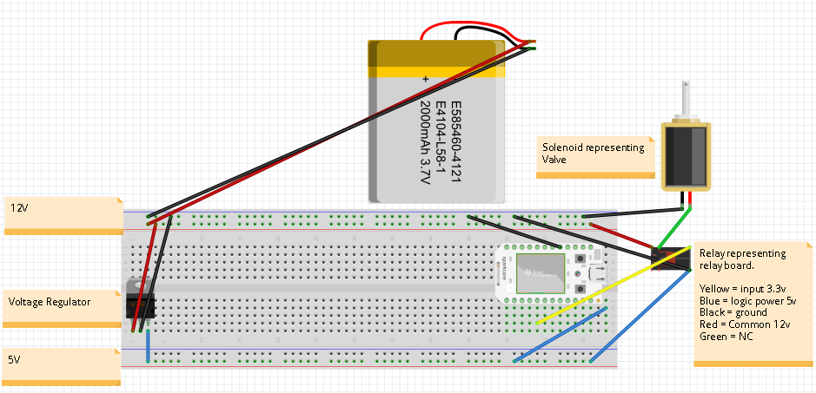
The system is contained entirely within a single unit. This unit contains a 12v, 7A battery, a 5v fixed voltage regulator, a 4 channel 5v relay board, and a Spark Core microcontroller. The Spark Core microcontroller contains a processor, a wifi module, and output pins. The wifi module connects to the Spark server, with the ability to publish information, and obtain requests from the server. The website has buttons that call POST requests to the Spark server, which call certain functions built into the Automated Irrigation firmware located on the Spark Core microcontroller.

2.2 Function Flows
The main feature of Automated Irrigation in this release is “Water Log Sleep”. This function begins the moment the “Water Log Sleep” button is pressed, which resides on the website.
The button first calls the javascript watering function, which calls a POST request to the Spark server to call the water() function on the firmware of microcontroller.
Then after a delay equal to the sum of watering times for each valve, the update() javascript function is called. This function makes a POST request to the Spark server that asks how long the microcontroller has been powered on for. This information is not used, but the timestamp for getting the information back is used. The timestamp serves a dual purpose. The first purpose ensures that the system is on and ready to receive POST requests (this implys that the water() method most likely executed without error). The second purpose is to log this information to determine the next watering time.
After a short delay, which is an estimation of the time it takes to make the POST request to the system and get a response back, the sleep() method is called. This makes a POST request with the parameter of the amount of seconds to sleep for. The purpose of the sleep method is to conserve battery power between watering times (shutting off WiFI module, shutting off LED). At this point , the system is completely unresponsive. After the specified time, it will return to the normal state.

2.3 User Access Levels
No distinct user access levels are defined. Automated Irrigation's activities should be completely transparent to its users. This is because transparency leads to a better understanding of how the system works, and an increased ability to adjust values quickly and easily.

System maintainers who wish to modify or adjust values in Automated Irrigation require access to the Spark account associated with the system, as well as the rights to modify the HTML and Javascript on the website.

2.4 Alternate Modes of Operation
Alternate modes of operation include the basic Water, Update, and Sleep buttons.

The water button calls the same water() method in the first part of “Water, Log, Sleep”, described in 2.2.

The update button calls the same method in the second part of “Water, Log, Sleep”, described in 2.2, however with a different parameter, to display the time that the system has been online and active for.

The sleep button calls the same method in the last part of “Water, Log, Sleep” described in 2.2.

3.0 GETTING STARTED

GETTING STARTED
Installing and Using Automated Irrigation

3.1 Initial setup
First ensure that all wires are secured to the breadboard. Then locate the long unconnected red wire and black wire. Connect the red wire to the terminal on the battery colored red. Connect the black wire to the terminal on the battery colored black. Automated Irrigation's status LED should flash green or blue. If it is slowly pulsing cyan, skip 3.1.1.

3.1.1 Connecting
Connects Automated Irrigation to a network
Unplug battery from Automated Irrigation, plug in microUSB to laptop. If the microcontroller's status LED is flashing green, hold down the mode button on the microcontroller until it is flashing blue. If not already available, download and install Spark CLI (command line interface). Run command prompt, enter spark setup. Follow the on-screen instructions (enter the SSID, then to choose a wifi security type (WPA, WPA2 or none), and then enter the password).

3.2 Using the website
Button Descriptions
    - Water Log Sleep:
Calls the Water function (see 3.2.2), the Sleep function (see 3.2.3), and a specialized version of the Update function (see 3.2.4), in order, spaced by estimated length of completion to minimize error.
      - Water:
Opens, waits, and closes every valve attached to the relay.
      - Sleep:
Stays in low power mode for a specified time. WiFi module is shut off, as well as status LED. After specified time is reached, Automated Irrigation resets itself.
      - Update:
Sends a POST request to the Spark server, which is the default server for Automated Irrigation, which has a built in Spark Core. This POST request prompts a publish request, which publishes certain information on the server, which is retrieved. In this case, it is used for displaying a time stamp, for future logging capability.

An ideal use of Automated Irrigation would be pressing the “Water Log Sleep” button on the website. This runs the watering sequence, displays the time that it finished watering, and then sets the system in the sleep state.

  - Adjusting Values
Adjusting specific values subject to change by watering requirements, etc.
*It is recommended that you make a backup of any code before adjusting values so that the backup can be loaded if problems occur.
    - Watering Time:
Open build.spark.io and log in. Open the current firmware, and identify lines 21, 24, 27, and 30. They should be similar to: valve1.wateringTime = 2000;
The default values are 2000, which is 2000 milliseconds or 2 seconds. Each valve's watering time can be adjusted to be as long or short as desired. This will affect the estimated timing in the javascript running on the website for line 33:
setTimeout(function(){update(30)}, 8000);
8000 should be replaced with the estimated sum of the time spent in the watering cycle, (for example, 2000 milliseconds for each of 4 valves is 8000 milliseconds).
It is important to adjust the next line from 10000 to the new value, plus 2000, for an extra 2 seconds to let the update method finish before going to sleep.
    - Sleep Time:
Sleep time is in seconds. There is no current user interface to easily adjust the amount of seconds that Automated Irrigation should sleep for. In the AutomatedIrrigation.html code line 12, for the sleep button declaration, replace sparkSleep(30) with sparkSleep(MySleepTimeInSeconds). Convert these seconds to milliseconds, and change line 38's “50000” to the Timeout specified in line 34 plus that converted sleep time. Add a 10 second buffer for starting up.
    - Valves:
The default amount of valves is 4. If more than 4 valves is required, a larger relay is needed. There are up to 16 channel relay boards by the same manufacturer which is a very simple swap. Open build.spark.io, log in, open the current firmware, and create new valves in the setup() function, and add them to the valve array. It may be needed to increase the memory allocated for valveArray from 5 to the number of total valves. Set the pinMode as seen in the setup() function, and initialize it to off (digitalWrite(pin, 1));. Lastly, increase the valves integer to the amount of valves.
Reducing the number of valves requires reducing the integer valves to the amount of valves, commenting out valve(s) with //, commenting out all setup procedures regarding that valve, and its corresponding pinMode for output.

4.0 TROUBLESHOOTING
- Troubleshooting

    - Status LED is flashing green:
This error means that the microcontroller is unable to connect to the network.
      - First check that power source is sufficiently charged
      - Ensure that the unit is not too far from router
      - If all else fails, and there is WiFi present, try:
      - 1.) Unplug battery, connect Automated Irrigation to computer using USB
2.) hold down both buttons and release the reset button, hold until flashes yellow
3.) Enter the following commands into the command prompt:
spark flash --factory tinker
spark flash --usb cc3000
once Automated Irrigation stops flashing purple, and starts flashing yellow again:
spark flash --usb tinker
6.) Enter the following and follow instructions:
spark setup wifi

    - System will not turn on/is unresponsive:
Check that the power source is sufficiently charged. Check for loose wires. If the power source is sufficiently charged, and is connected, it is likely that the system is in sleep mode. If it is desired that the system is not in sleep mode, disconnect power from the system and reconnect it. If the system does not power on, there may be a hardware related issue.

    - System is not watering properly:
Adjust values as needed (see 3.3). Also ensure that the “Water Log Sleep” button is being pressed, and is only pressed once. The next release will ensure that the button is protected against accidental multiple presses.

For help fixing unresolved issues, or reporting a new issue, contact Christopher DeMartin (christopherdemartin@mail.adelphi.edu).

